Name:
Tutor:
Course:
Date:
Graphical Assignment
Desmos.com link – https://www.desmos.com/calculator/j3xtq7qcip
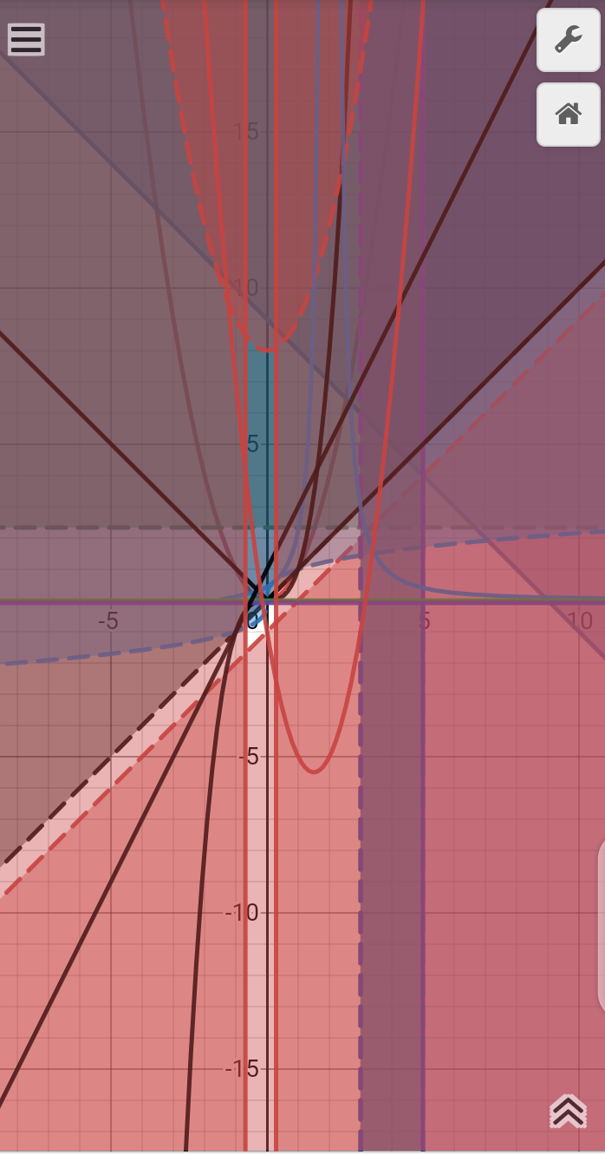
Fig 1: graphs of functions
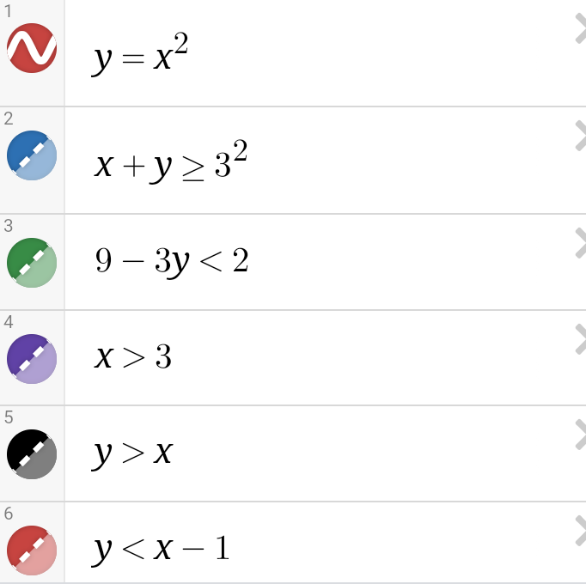
Fig 2: functions 1 to 6
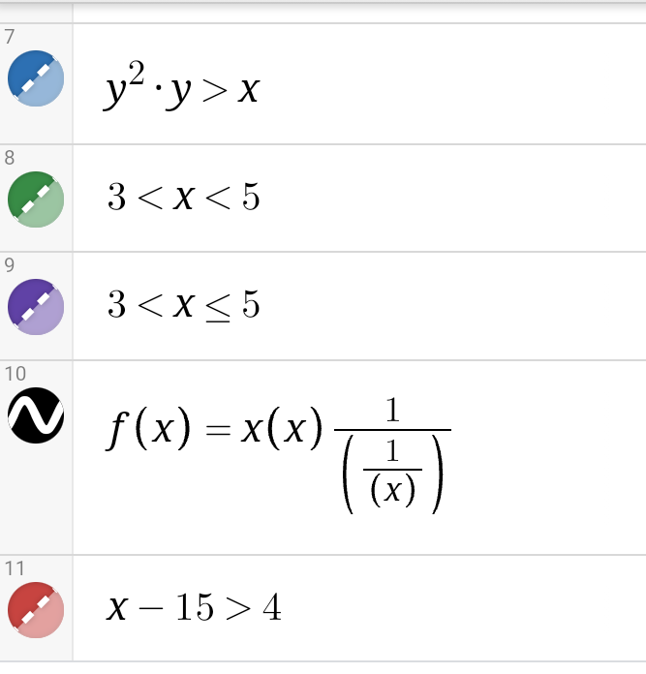
Figure 3: functions 7 to 11
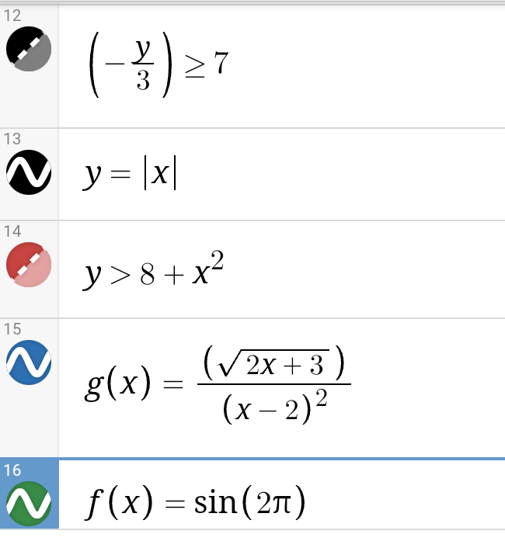
Figure 4: functions 12 to 16
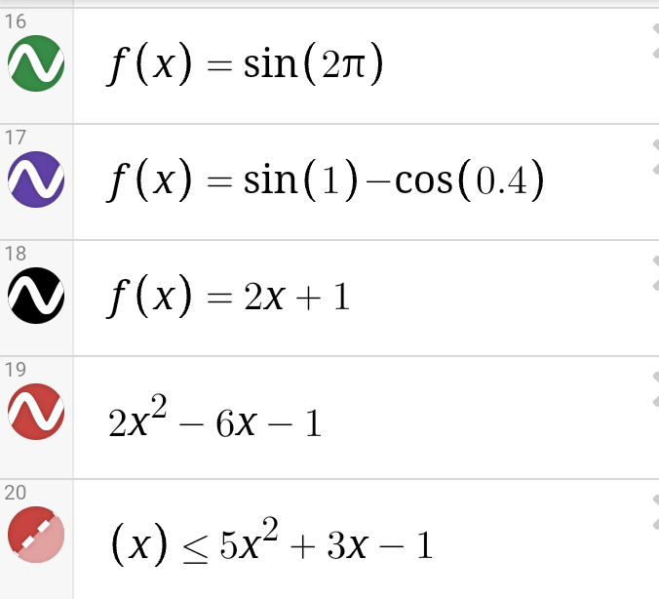
Figure 5: functions 16 to 20
After the first draft of the graphical assignment, there are several changes that I would like to make. One is to ensure that all functions are presented in an orderly manner. I would prefer to begin with simple functions like linear functions and conclude with composite and identity functions. Using this order would be easier to understand. Another change I would make to improve my draft is to have different lines and color for each function. Using different lines and color for each function would be necessary to help differentiate them easily. Using this approach would also make the presentation visually appealing.
A major challenge I faced when performing the project was failing to include conditions for modulus and signum functions. It was challenging to include these conditions because I could not find all the characters I required. Another challenge was how to use different lines for each of the functions. When I tried to change the lines for these functions, the graph changed and I was worried that all the work would have been lost before saving. It was challenging to use the input composite functions because I could not find & in the graph to combine the two functions. Aldo, at first, I did not include different functions because I had not understood the assignment. Failing to understand on the first trial prompted me to attempt the assignment three times.
There are several things that I learned about functions. One is that a function has only one relationship for each of the input values. This implies that a function cannot give two different results for the same input. Therefore, a function is single valued. The second thing I learned is that the output of a function is always related to the input. A function should work for every input values. This implies that it is universal and helps relate one element in a set with another element in another set. Functions can be used to process many things like height, speed, flow rate, temperature change, and airflow. This means that functions can be used to help solve problems in the modern world.
This tool is important and I can use it in the future to further my math skills and express my creativity. By learning how to enter different functions, I will be able to develop different graphs and turn them into realistic and complex drawings. I will use this tool to enhance my understanding of composite functions and how they apply in real life situations. I will use this tool to learn how functions operate and how changing the inputs affects the outputs. Also, this tool will be helpful in the development of graphs showing how changing the values affects the function itself. Besides, I will use the application to learn how I can color graphs differently. Using these colors in graphs will be helpful because it will help me connect mathematical concepts to the colors and shapes in the real world.

